

1. Introduction

1.1 Context
The U.S. healthcare system is at a tipping point. Costs are skyrocketing, chronic disease rates continue to climb, and mental health disorders are silently fueling this crisis. Today, more than one in five American adults (23.1%) lives with a mental illness—approximately 59 million people. Yet fewer than half receive treatment, leaving millions vulnerable to worsening health and financial strain. Untreated mental health conditions cost the U.S. economy an estimated $282 billion annually, equivalent to the impact of a major recession. When combined with chronic conditions, this burden accounts for 90% of the nation’s $4.9 trillion healthcare spending. These numbers underscore a stark reality: ignoring mental health is no longer an option.
- Annual Cost of Mental Illness: Mental health conditions cost the U.S. economy $282 billion annually, equivalent to 1.7% of national consumption.
- Healthcare Spend Impact: 90% of the $4.9 trillion U.S. healthcare expenditure is for individuals with chronic and mental health conditions combined.
- Inequity Costs: Mental health inequities add $477 billion annually in avoidable costs; projected to reach $1.26 trillion per year by 2040 if unaddressed.
- Indirect Costs: Lost productivity, absenteeism, and disability claims significantly increase employer and societal burden.
- Comorbidity Effect: Untreated behavioral health issues lead to higher medical costs, more ER visits, and longer hospital stays.
- ROI Opportunity: Integrated behavioral-medical care models demonstrate measurable cost savings and improved outcomes under value-based care frameworks.

1.2 Problem Statement
Stress, anxiety, and depression are not isolated issues, they are catalysts for physical disease. Chronic stress disrupts nearly every system in the body, increasing risks for cardiovascular disease, diabetes, obesity, and sleep disorders. Anxiety and depression accelerate the onset of heart disease and other chronic conditions, creating a vicious cycle of declining health and rising costs. The longer these conditions remain undetected, the more complex and expensive they become to treat. This is why early intervention is critical—and why the current model, which often separates mental and physical health care, is failing.

1.3 Proposal - Early Intervention
Primary Care Physicians (PCPs) are the ideal point of intervention. They are the first touchpoint for most patients and manage most chronic conditions. Approximately 40% of office visits for mental health concerns occur in primary care settings, and nearly half of all prescriptions for mental illness are written by PCPs. Yet, PCPs rarely have the tools or training to identify mental health issues during routine visits. By integrating basic mental health screening into initial patient assessments, PCPs can detect early signs of psychological distress before they escalate. This approach not only improves patient outcomes but also reduces unnecessary hospitalizations, emergency visits, and long-term treatment costs. Empowering PCPs with mental health screening capabilities transform them from gatekeepers of physical health into champions of holistic care.
The urgency is clear: without systemic changes that prioritize mental health at the primary care level and expand access to psychiatrists, psychologists, and counselors, the U.S. will continue to bear unsustainable healthcare costs. Integrating mental health into primary care is not just a clinical improvement, it is an economic imperative.

2. Evidence Linking Mental Health to Healthcare Costs
Common Mental Health Conditions
Post-Traumatic Stress Disorder (PTSD)
• A mental health condition triggered by experiencing or witnessing a traumatic event (e.g., accidents, violence, disasters).
• Symptoms include flashbacks, nightmares, severe anxiety, and uncontrollable thoughts about the event.
• Around 6–8% of adults experience PTSD at some point; higher rates among veterans and trauma survivors.
Depression
• A mood disorder causing persistent feelings of sadness, hopelessness, and loss of interest in daily activities.
• Leads to fatigue, poor concentration, and physical symptoms like sleep disturbances.
• Affects over 21 million adults in the U.S. annually; untreated depression increases risk of chronic illnesses and suicide.
Anxiety Disorders
• A group of conditions characterized by excessive fear or worry, including generalized anxiety disorder (GAD), panic disorder, and social anxiety.
• Symptoms include restlessness, rapid heartbeat, sweating, and avoidance behaviors.
• Most common mental health condition globally; affects nearly 30% of adults at some point in life.
Bipolar Disorder
• A mood disorder marked by alternating episodes of mania (high energy, impulsivity) and depression.
• Disrupts daily functioning, relationships, and work productivity.
• About 2.8% of U.S. adults experience bipolar disorder annually; often misdiagnosed, leading to delayed treatment.
Obsessive-Compulsive Disorder (OCD)
• A condition involving intrusive thoughts (obsessions) and repetitive behaviors (compulsions) aimed at reducing anxiety.
• Common compulsions include excessive cleaning, checking, or counting.
• Affects about 1–2% of the population; often begins in adolescence or early adulthood.
Substance Use Disorder (SUD)
• A chronic condition where individuals compulsively use substances (alcohol, drugs) despite harmful consequences.
• Leads to physical health issues, financial strain, and increased risk of mental illness.
• Over 20 million Americans struggle with SUD; high comorbidity with depression and anxiety.

2.1 Biological and Behavioral Pathways
Mental health disorders such as stress, anxiety, and depression exert profound physiological effects that directly influence physical health outcomes. Stress activates the hypothalamic-pituitary-adrenal (HPA) axis, triggering a cascade of hormonal changes that elevate cortisol levels. Prolonged activation of this system leads to metabolic dysregulation, immune suppression, and heightened cardiovascular risk, creating fertile ground for chronic illnesses like diabetes and hypertension. Similarly, depression is associated with systemic inflammation, disrupted sleep cycles, and impaired cognitive functioning, which collectively hinder a patient’s ability to adhere to treatment plans and make informed health decisions. These biological and behavioral pathways illustrate why mental health cannot be siloed from physical health—untreated psychological distress accelerates disease progression and complicates management of existing conditions.

2.2 Economic and Epidemiological Evidence
The economic implications of untreated mental health conditions are staggering. Patients with untreated depression incur two to three times higher medical costs compared to those receiving appropriate care. When mental illness coexists with chronic diseases such as diabetes or cardiovascular disorders, healthcare spending rises by 30–50%, driven by frequent hospitalizations, emergency visits, and complex treatment regimens.
Somatic symptom disorders, where psychological distress manifests as physical complaints, result in millions of unnecessary diagnostic tests annually, including MRIs, CT scans, and laboratory work, adding billions to healthcare expenditures without improving outcomes. Beyond direct medical costs, the U.S. economy loses over $200 billion each year in productivity due to absenteeism, presenteeism, and disability linked to mental health issues. These figures underscore the dual burden of clinical and economic inefficiency caused by inadequate mental health integration.

2.3 Case Examples
Real-world data further highlight the cost implications of mental health comorbidities.
- Diabetes + Depression: Increases healthcare costs by ~$2,000–$3,000 per patient annually.
- Cardiovascular Disease + Anxiety: Significantly higher emergency department (ED) usage.
- Irritable bowel syndrome (IBS) and Chronic Pain Disorders: Strongly linked to psychosocial stress, leading to frequent PCP visits.

3. Gaps in Current Primary Care Mental Health Integration
Despite growing recognition of the link between mental health and physical health, primary care remains under-equipped to address psychological concerns effectively. Several systemic gaps and operational challenges hinder integration:

3.1 Lack of Time and Training
Primary Care Physicians (PCPs) are often the first point of contact for patients, yet they operate under intense time constraint (typically 15–20 minutes per visit) while managing multiple chronic conditions. This leaves little room for mental health screening. Compounding this issue, most PCPs receive minimal behavioral health training during medical education, leading to hesitancy in identifying and managing psychological concerns.

3.2 Overuse of Diagnostics
In the absence of structured mental health screening, patients presenting with stress-related somatic symptoms such as headaches, fatigue, or gastrointestinal discomfort frequently undergo costly diagnostic tests (MRIs, CT scans, lab panels). These tests rarely reveal an organic cause, yet they inflate healthcare costs and delay appropriate care. This pattern reflects a systemic gap where physical symptoms are prioritized over underlying psychological drivers

3.3 Referral Constraints
Even when mental health issues are identified, referral pathways are constrained. The U.S. faces a shortage of approximately 8,000 psychiatrists, with wait times stretching from weeks to months in many states. Limited availability of psychologists and counselors, especially in rural areas, exacerbates delays and increases reliance on emergency departments for crisis management.

3.4 Operational Challenges
- Workflow and Technology Barriers: Integrating mental health checks into existing electronic health record (EHR) systems is technically complex and resource intensive.
- Patient Reluctance: Cultural stigma and privacy concerns often make patients hesitant to disclose mental health symptoms during routine visits.
- Reimbursement Limitations: Inconsistent or inadequate reimbursement for mental health screening discourages adoption in primary care settings.

4. Proposed Solution: Integrating Mental Health Screening into Primary Care
The proposed solution aims to embed mental health screening and predictive analytics into the primary care workflow, enabling early detection, reducing stigma, and ensuring coordinated care. This approach leverages real-time screening, historical data analysis, and team-based interventions to address systemic gaps and operational challenges.

4.1 Real-Time Screening at PCP Level
When a patient visits a Primary Care Provider (PCP), a brief mental health screening (e.g., PHQ-9 for depression, GAD-7 for anxiety) is conducted during the initial assessment. This step empowers PCPs to identify potential mental health risks without requiring specialized psychiatric resources. Screening at the PCP office reduces stigma and encourages patients to engage in early interventions.
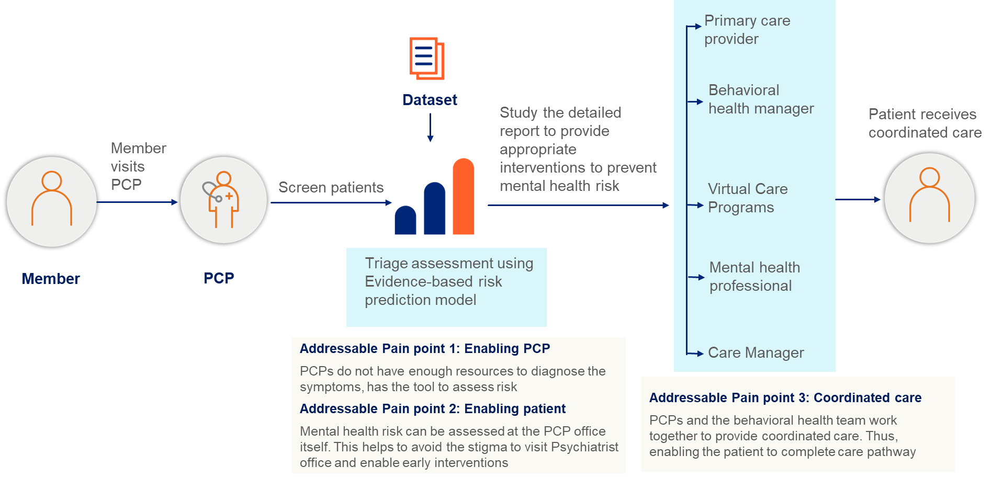

Approaches to Integrating Physical and Behavioral Health Care
Approach | Description | Examples
Coordinated (Driven by communication) | Screening: Primary care providers (PCPs) identify patients with behavioral health needs and refer them to services  Consultation: Behavioral health consultants work with patients to meet care goals established by PCPs | Screening, Brief Intervention, and Referral to Treatment (SBIRT)  Vermont’s Hub and Spoke Model
Colocated (Benefits from proximity) | Care management/navigation: Behavioral health care managers embedded within primary care practice monitor patients’ care plans and treatment progress and coordinate behavioral health care with patients and PCPs  Colocation: PCPs and behavioral health providers operate from same facility and collaborate as needed | Collaborative Care Model and Comprehensive Primary Care Plus Model  Common in FQHCs, like the Cherokee Health Systems and Golden Valley Health Centers
Integrated (Fully transformed care) | Health homes: Health homes offer ongoing care management and coordination, referrals, and support for patients with complex needs, addressing range of health needs, including behavioral  System-level integration: PCPs and behavioral health providers from same facility coordinate and collaborate under one management system; communication, culture of respect, collaboration are key | Medicaid Health Homes  Intermountain Healthcare

4.2 Risk Prediction Model
Imagine a primary care clinic that wants to spot patients at rising risk for mental-health needs before crises occur. Screening results from routine visits don’t just sit in a chart—they fuel an evidence-based risk prediction engine that brings together:
- Historical claims (e.g., mental-health service utilization over the past two years),
- Patient clinical profiles (diagnoses, severity scores), and
- Survey responses and behavioral indicators.
Using machine learning, the engine triages patients by risk severity and delivers actionable insights to Primary Care Providers (PCPs) and Behavioral Health Integration (BHI) teams. The goal: personalized, proactive interventions that reduce unnecessary diagnostics and improve care efficiency.
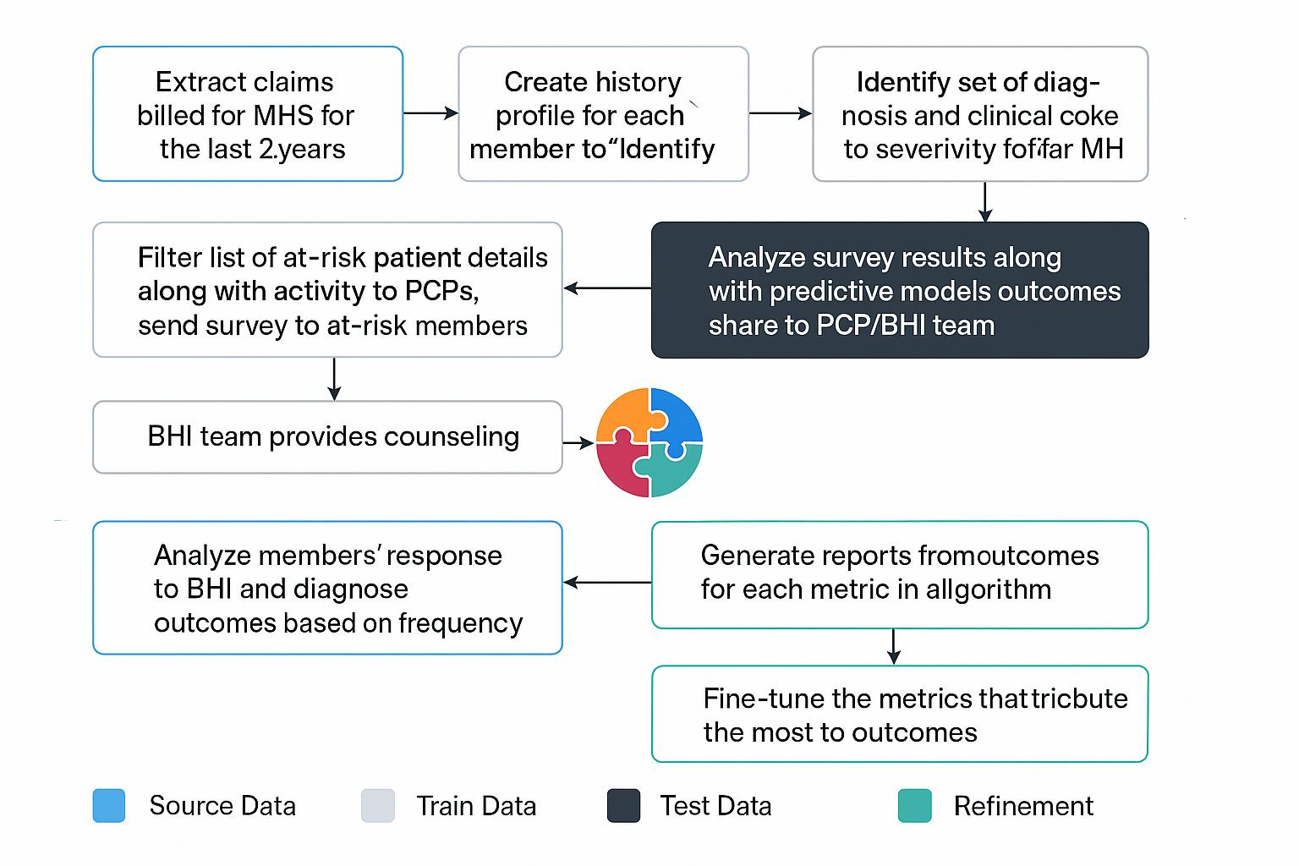

From Screening to Action: How the Pipeline Works
A patient completes a brief mental-health screening during a routine PCP visit. That screening triggers the pipeline below. Within hours, the PCP and BHI team receive a concise, data-rich view of the patient’s recent mental-health service use, clinical history, and survey sentiment, along with a risk tier (e.g., low, moderate, high) and suggested next steps (outreach, counseling, survey follow-up).
Behind the scenes, the process unfolds in ten tightly connected steps.

The end-to-end pipeline (Step-by-Step)
Key acronyms used below
MHS = Mental Health Services
MH = Mental Health
CPT = Current Procedural Terminology (procedure codes)
PCP = Primary Care Provider
BHI = Behavioral Health Integration team
Step 1: Collect Source Data
Action: Extract claims billed for MHS for the last 2 years from UFE E&I claims.
Output: Persist the raw and curated extracts in Galaxy DB as the system of record for downstream modeling.
Step 2: Create Member History
Action: Build longitudinal member history profiles in Scala to summarize utilization patterns, care episodes, and likely causes for MHS.
Output: Feature-ready histories linked to each member ID.
Step 3: Identify Diagnosis Codes
Action: Determine the set of diagnosis and clinical codes that contribute most to MH severity (e.g., mood disorders, anxiety, substance use).
Output: A code library used by feature engineering and filtering.

Step 4: Filter and Prepare Training Data
Action: From daily claims, filter records containing relevant MH CPT and diagnosis codes identified in Step 3.
Output: Produce clean, labeled training datasets for ML (features such as frequency of services, recency, severity indicators).
Step 5: Share Risk Details
Action: Deliver at-risk member lists and associated activities (e.g., outreach needed) to PCPs.
Output: Trigger surveys to at-risk members to capture current symptoms and self-reported stressors.
Step 6: Collect and Analyze Survey Data
Action: Ingest responses from Sanvello / Live and Work Well surveys.
Output: Combine survey signals with predictive model outputs to refine the risk tier and recommended actions.
Delivery: Share consolidated insights with PCP/BHI teams.
Step 7: Counseling
Action: The BHI team provides counseling informed by both the survey findings and predictive analysis.
Output: Match the intensity of support (e.g., brief intervention vs. scheduled therapy) to the member’s risk level.
Step 8: Analyze Responses
Action: Evaluate members’ responses to BHI outreach and counseling over time, tracking frequency
Output: (e.g., appointment adherence, symptom improvement).
Step 9: Generate Reports
Action: Produce standardized reports on each algorithmic metric (utilization, severity markers, outreach effectiveness).
Output: Operational and clinical dashboards for governance.
Step 10: Refine Metrics
Step 10: Refine Metrics
Action: Continuously fine-tune features and thresholds that drive the strongest outcome improvements.
Output: Updated model parameters and improved workflow recommendations

What do PCPs and BHI teams see?
When the care team opens the care dashboard, they see a clear risk summary - for example, High risk due to recent claim spikes and severe diagnosis codes. A brief member history highlights key drivers like utilization frequency, recency, and symptom severity, while survey sentiment adds the human view with notes on sleep disturbance, mood rating, and activity level. Guided by these signals, the system proposes recommended actions - a warm outreach call, counseling scheduled soon, and a follow-up survey. As the BHI team engages, tracking dashboards update in real time, letting providers monitor member progress and overall program effectiveness, keeping care responsive, personal, and focused on what helps most.

Technical Architecture Summary

- Computer & orchestration: Kubernetes + Spark
- Languages: Scala (member history & features), Python/Spark ML (optional for modeling)
- Data store: Galaxy DB (curated claims, features, and model outputs)
- Data model: Fact tables for claims and surveys; dimension tables for members, codes, providers
- ML outputs: Risk tier, contributing factors, confidence score
- Feedback loop: Outcomes and engagement feedback to refine features and thresholds

Governance & quality
The data lineage runs from UFE E&I claims into Galaxy DB, where records are curated into feature sets and then transformed into risk outputs, ensuring full traceability end to end. Privacy is safeguarded through appropriate controls on survey and clinical data, with access restricted to authorized PCP and BHI roles only. Ongoing monitoring captures model performance and operational KPIs, and retraining is initiated as new or updated data becomes available. Finally, a continuous-improvement loop; anchored in Steps 9 and 10 ;allows the system to learn from outcomes and engagement signals, refining the most impactful features and thresholds over time.

4.3 Addressing PCP Challenges Through Integration and Incentivization
- As primary care providers (PCPs) take on additional responsibilities through behavioral health integration, it is essential to compensate for the extra time, coordination, and complexity involved in patient management. We recommend implementing structured incentive programs that align financial rewards with improved outcomes and provider engagement. These programs should include performance-based bonuses tied to mental health screening rates, follow-up adherence, and patient outcomes, as well as shared savings models that allow PCPs to benefit from reduced hospitalizations and emergency visits. Tiered payments and timely disbursements can further motivate providers to continuously improve care quality while offsetting the administrative burden of integrated care.
- Insurers play a critical role in operationalizing these incentives by ensuring transparency, timely payments, and robust data feedback loops. Bundled payments or capitation models can simplify reimbursement for comprehensive care, while linking bonuses or penalties to quality metrics ensures accountability. Aligning these strategies with federal initiatives such as Medicare Shared Savings and VBID will enhance scalability and sustainability. By directly rewarding PCPs for their expanded role in behavioral health integration, these mechanisms foster provider engagement, improve patient outcomes, and support a cost-effective, patient-centered healthcare system.

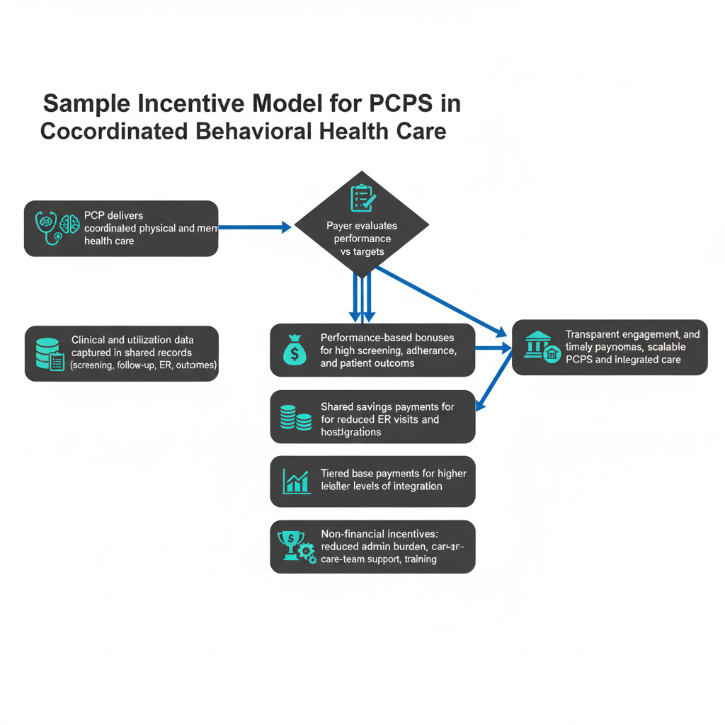

4.4 Coordinated Care Pathway -From risk signal to responsive, connected care
A patient completes a brief MH screening during a routine PCP visit. The pipeline (Steps 1–6) runs in the background; claims and survey signals are combined, a risk tier is assigned, and a concise summary reaches the care team within hours. Now the coordinated pathway kicks in.
How the pathway unfolds (and how it ties to Steps 5–8):
- PCP stays at the center - care orchestration begins (Pipeline Steps 5–7)
The PCP receives the at-risk member list with contributing factors and recommended actions. They anchor the care plan: set goals, align medical + behavioral needs, and coordinate warm outreach rather than cold referrals.
- Behavioral health team delivers counseling and therapy (Pipeline Step 7)
Behavioral Health Managers and mental health professionals tailor intervention intensity to the risk tier (e.g., brief intervention for moderate risk; scheduled therapy for high risk). Shared notes and standing care agreements keep PCP and BHI aligned.
- Virtual care extends access and reduces delays (Supported by Steps 6–7; monitored in Step 8)
Telehealth sessions, secure messaging, and self-guided modules offer flexible access - critical for remote or underserved members. Rapid scheduling compresses time-to-first-visit and lowers no-show risk.
- Care managers monitor adherence and outcomes over time (Pipeline Step 8)
They track session attendance, medication follow-through, escalation flags, and symptom change. Proactive nudges and barrier removal (transport, scheduling, digital literacy) keep care moving.
- Preventive and lifestyle integration supports long-term wellbeing (Pipeline Step 7, integrated into treatment plans)
Mindfulness sessions, yoga, stress-management techniques, and tailored nutrition/lifestyle guidance are embedded in the care plan to strengthen resilience and sustain improvement.
This coordinated model delivers continuity of care by keeping the PCP at the center, ensuring every role moves with the patient rather than around them. Warm handoffs and virtual options compress time to intervention, reducing delays that typically arise from referral bottlenecks. With multimodal access - clinic visits, telehealth, secure messaging, and mobile tools; care meets members where they are, driving higher engagement and more consistent follow-through.

4.5 Continuous Improvement Loop- Turning Care Data into a Learning Health System
Once care begins, the pipeline becomes a learning loop. We track how people respond - appointment adherence, symptom changes, and engagement - and compare what works best across modalities and risk tiers (Step 8). Those signals roll into clear, outcome-based dashboards that show “what works for whom” (Step 9). Then we tune the model; re-weighting features and adjusting thresholds; so risk tiers and recommendations get sharper and more useful (Step 10). In short, it’s a learning health system where real-world data quietly improves care, outcomes, and costs with every cycle.
Result: a learning health system
Data continuously informs care decisions, targeting the most effective levers, improving member outcomes, and focusing resources where they matter most.
Mini-Scenario:
- Day 0–1: Screening triggers the pipeline (Steps 1–6). PCP/BHI receive the consolidated view with risk tier and next steps.
- Week 1: Warm outreach; counseling scheduled; mindfulness introduced (Step 7).
- Weeks 2–6: Care managers track adherence and symptom trends; dashboards update in real time (Step 8).
- Quarterly: Reports highlight best outcomes for a specific cohort (e.g., virtual CBT + brief mindfulness + monthly PCP touchpoints) (Step 9).
- Next cycle: The model reweights features; thresholds are tuned to prioritize rapid scheduling and combined interventions (Step 10).

5. Managing the Mental Health Workforce Scarcity

5.1 Directing Patients to the Right Level of Care: A Scalable, Team-Based Approach
To ensure that preliminary mental‑health screening at the primary care level leads patients to the most appropriate point of care, we want to emphasize on a tiered workforce strategy that optimizes scarce psychiatric resources while leveraging the full ecosystem of mental‑health professionals. By expanding the mental health workforce beyond psychiatrists to include psychologists, therapists, licensed social workers, behavioral health professionals, and care managers, we enable effective distribution of responsibilities based on clinical severity. Psychologists and therapists can manage mild to moderate conditions through evidence‑based psychotherapies, while psychiatrists concentrate on complex or high‑acuity cases that require specialized expertise. Building on WHO‑endorsed task‑shifting frameworks, trained non‑specialists—such as nurse practitioners, social workers, and behavioral health coaches—can deliver foundational interventions under structured supervision, thereby reducing bottlenecks at the specialist level. Embedding this within a stepped‑care model further enhances efficiency: patients begin with the least intensive, most accessible level of support, and progress to higher-intensity services only if needed. This creates a dynamic, responsive system that ensures rapid connection to appropriate care, preserves psychiatric capacity for the most critical cases, and maintains high-quality, scalable mental‑health service delivery.

5.3 Integrated Care Models
Models with proven cost savings:
- Collaborative Care Model (CoCM) [2,6,7]: $6 in savings for every $1 invested.
- Stepped Care Model: Efficient use of specialist resources.
- Behavioral Health Integration (BHI): CMS reimburses integrated mental health services.

6. Cost-Benefit Analysis
Implementing mental health screening and integrated behavioral care in primary care offers a strong return on investment by reducing preventable medical spending, improving clinical outcomes, and lowering productivity losses. Although individuals with behavioral health conditions make up only 5.7% of the insured population, they account for 44% of total healthcare costs, and untreated mental illness drives $282 billion in annual economic losses. Evidence from U.S. health systems shows that the Collaborative Care Model (CoCM) reduces healthcare costs by up to 13% per member per month, with savings beginning in the first year. Long-term studies report up to a 6:1 ROI—including $3,365 in savings per patient over four years—driven by fewer emergency department visits, avoidable hospitalizations, and unnecessary diagnostic testing.
Beyond direct healthcare savings, the broader economic impact is substantial. Untreated depression alone results in $44 billion in lost productivity annually, and patients with unaddressed behavioral health needs incur 2–3× higher medical-surgical costs. Integrated primary care models improve adherence and chronic disease management, reducing costly complications. National modeling by the American Psychiatric Association and Milliman indicates that effective medical-behavioral integration could save $26–$48 billion annually, while federal analyses suggest that aligning integration with value-based programs like MSSP could reduce federal spending by $767 million to $3.8 billion over a decade. Together, the data show that primary-care–based mental health integration is not only clinically urgent but also one of the most financially impactful strategies available to health systems, payers, employers, and the U.S. economy.
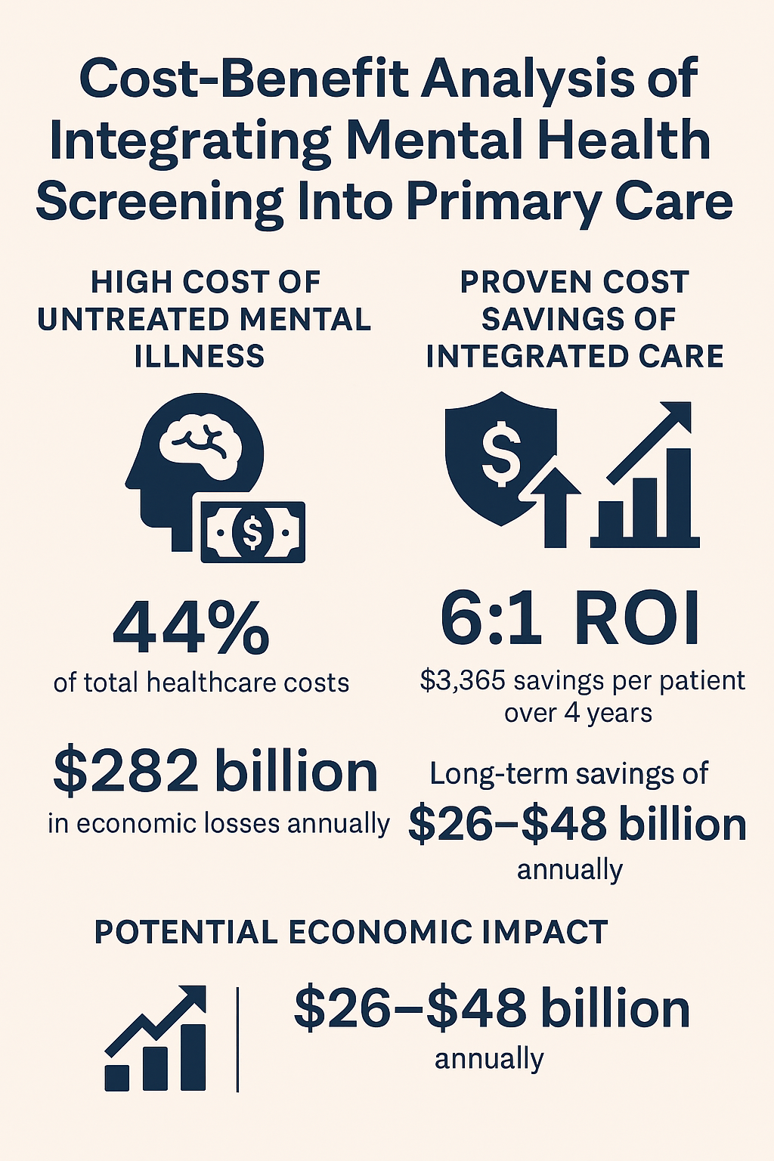

7. Expanded Role of Insurance Companies
Insurance companies (payers) can accelerate adoption because mental health screening aligns with financial, clinical, and regulatory priorities.

7.1 Why It Matters to Insurers
- Mental health drives higher medical claims for chronic illnesses.
- Payers face rising MLRs due to unmanaged behavioral health needs.
- Screening is inexpensive and reduces high-cost events.

7.2 Payer-Led Initiatives to Support Screening
- Reimbursement for Mental Health Screening
  - Create CPT-coded incentives for PCPs.
  - Guarantee coverage for CoCM and BHI services.
- Value-Based Care Alignment
  - Mental health metrics can be tied to shared savings programs.
  - Screening can become a quality requirement.
- Data-Driven Risk Stratification
  - Payers can use screening results to identify high-risk patients early.
  - Reduces future catastrophic claims.
- Network Expansion & Teletherapy Partnerships
  - Insurers can contract with tele-mental health providers to reduce referral bottlenecks.
- Employer-Focused Health Programs
  - Support employers with integrated mental health benefits.

7.3 Payer ROI Example
For a payer covering 100,000 members:
- Annual screening cost: ~$500,000
- Expected savings from reduced claims: $7M–$12M
- Net savings: $6.5M–$11.5M

8. Implementation Framework
Implementing mental health screening in primary care works best with a simple, phased approach. It starts with piloting the screening process in a handful of clinics, allowing teams to test workflows and gather feedback. Next, the screening results are woven into everyday care pathways, helping providers make timely, informed decisions. Once the process is running smoothly, the program can expand across the entire provider network. To support this rollout, practices need a few key infrastructure updates like EHR enhancements, secure ways to share data, and telehealth capabilities to connect patients with behavioral health support. Just as important is preparing the care teams themselves. PCPs benefit from short, practical training modules, clear referral guidelines, and ongoing supervision or consultative support, ensuring they feel confident and supported as they incorporate mental health screening into routine care.

9. Sources

- CBA
  - Building the Business Case for Team-Based Integrated Care - AIMS Center
  - CoCM_Total_Healthcare_Costs_Issue_Brief_Press_Release.pdf
  - Novel study quantifies immense economic costs of mental illness in the U.S. | Yale News
  - Collaborative Care Model Reduces Total Health Care Costs - CHRO Association
  - Milliman-Summary-Report-Economic-Impact-Integrated-Implications-Psychiatry.pdf
  - HMA-Report-for-BPC.pdf

Notes and Rough work (to be taken out later)

EHR, there is lack of interconnectivity
PCP has to sort of a central pillar

Concerns
Wait time to get onto PCP panel, lot of PCPs are not ready to take on new patients – 3 to 6 months wait time
There must be some incentive – some compensation newer work. Billing by procedure code. Reimbursement has a cascade effect. Medicaid does not pay for everything, telehealth
Right point of care was not provided initially – you will need more social workers, mental health workers, psychiatrist or psychologists
Data piece has been interesting – risk score
Do you want to share a mental health data with insurers
We will have to dig more

PCPs
Refine approach

PCPs are in an advantageous position
Not going for government policies, we can think of incentives – or is there any other way
Audience & Tone
- Strategic for Executives
- Technical for Actuaries

Sections
- Executive Summary
  - Key findings and strategic recommendations.
- Introduction (All)
  - Mental health prevalence and its impact on U.S. healthcare economics.
- Challenges – (Indhu, Apurva)
- c
Cost Impact
- 90% of the U.S. $4.9 trillion annual healthcare expenditure is for people with chronic and mental health conditions combined.
- Mental illness alone costs the U.S. economy $282 billion annually, equivalent to 1.7% of national consumption—comparable to a recession-level impact.
- Mental health inequities add $477 billion annually in avoidable costs and could reach $1.26 trillion per year by 2040 if unaddressed.
- Untreated behavioral health conditions lead to higher medical costs, more ER visits, and longer hospital stays, driving up total cost of care.
Economic Burden of Mental Health
Challenges in empowering PCPs with mental health checks
- PCPs face heavy workloads, making it difficult to add mental health screening without disrupting schedules.
- Many PCPs lack specialized behavioral health training, leading to hesitancy in identifying concerns.
- Integrating mental health checks into existing workflows and EHR systems can be technically complex.
- Patients may be reluctant to share mental health information during routine visits.
- Limited reimbursement for mental health screening in primary care settings discourages adoption.
- Ensuring consistent and standardized screening practices across PCPs requires clear guidelines and monitoring.
  - How mental health issues are leading to more and more physical diseases day by day
  - Data on how this increase leads to added costs
  - Pricing mental health benefits.
  - Risk adjustment models (ACA, Medicare Advantage).
  - Predictive analytics for behavioral health.
  - Economic Burden - Quantitative analysis of mental health costs and inequities.
- Regulatory Compliance - (Rajat)
  - MHPAEA parity testing (QTL/NQTL).
  - Actuarial role in compliance audits.
- Strategic Integration – Steps which we suggestion (Ashish, Ekta, Indhu, Apurva)
- Adding some mental heath related questions in the initial analysis/questionnaire
- Empower PCPs – put a check in PCP analysis,
- Based on past claims, patient profiling can be done to categorize if the patient fall in a mental health issue
  - ROI of integrated behavioral-medical care.
  - Value-based care implications.
- Future Directions
  - AI-driven risk scoring.
  - Equity-focused actuarial frameworks. (To be discussed with Ankit)
- Recommendations
  - For actuaries: Model enhancements.
  - For executives: Investment priorities.
- References

Update call: 1/7/2026
- Too many bullets in progress document
- Too much pivoting
- Lets talk about the extreme like ADHD

